DTMF Decoder

Define DTMF, history behind it and explain how it works

Applications of DTMF

prototyping

test data

testing in prototyping phase

java implementation

testing java program

possible improvements

conclusion

Introduction
This is a project to develop a JAVA program to implement a DTMF decoder.

DTMF stands for Dual Tone Multi Frequency. This is an in-band telecommunication signaling system using voice-frequency band over telephone lines between telephone equipment and other communications devices and switching centers. DTMF was first developed in the Bell System in the USA, and became known under the trademark Touch-Tone for use in the pushbutton telephones supplied to telephone customers, starting in 1963.[1] DTMF replaced the clockwork dial made of moving parts which was getting more and more impractical to use as the number of telephone users increased exponentially.

How DTMF works [2]
DTMF uses a 12 or 16 button keypad. Each key generates two tones of different frequencies; one from DTMF High Frequency group and the other from DTMF Low Frequency group. The combination of the two tones will be distinctive and different from tones of other keys and these tones cannot be mimicked by voice or random signals. The DTMF Frequencies are shown in the figure below:
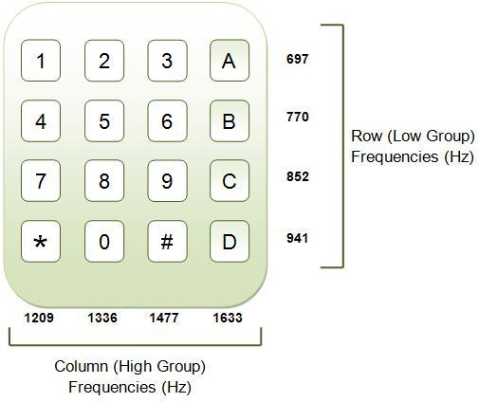
Figure 1: Diagram showing the DTMF Low and High Frequencies for each key on a telephone keypad.[2]

Applications of DTMF

// TODO

Prototyping

First step was to create sample test tones in Audacity with a bit rate of 8kHz. These will be pure DTMF tones, each tone will be approximately 160ms with silences of 96ms.
Because I knew the exact frequencies I was looking for, I used Goertzel’s Algorithm to extract a frequency spectrum of the frames showing just the DTMF frequencies. A short insight into Goertzel’s Algorithm.
// TODO
Next I had to determine the size of the frames that will be used for decoding the data. After research and advice from Albert, for the Fast Fourier Transform to work fast, the frame sizes should have 2n samples. Because of this restriction, the frame length range from 22ms to 45ms. For popular sample rates, the frames sizes are as follows:
Sample Rate (Hz) | Frame size used in program
8000 | 32ms (256 samples)
11 025 | 23ms (256 samples)
16 000 | 32ms (512 samples)
22 050 | 23ms (512 samples)
32 000 | 32ms (1024 samples)
44 100 | 23ms (1024 samples)
48 000 | 43ms (2048 samples)
96 000 | 43ms (4096 samples)
176 400 | 23ms (4096 samples)
192 000 | 43ms (8192 samples)
352 800 | 23ms (8192 samples)
Figure 2: Table showing the frame sizes used for corresponding sampling rates.

After splitting the data into short frames, each of these frames will be filtered using the Goertzel function in MatLab. I created a function which returned an array DFT data of the DTMF frequencies in each of the frames. A plot of these arrays is shown below:
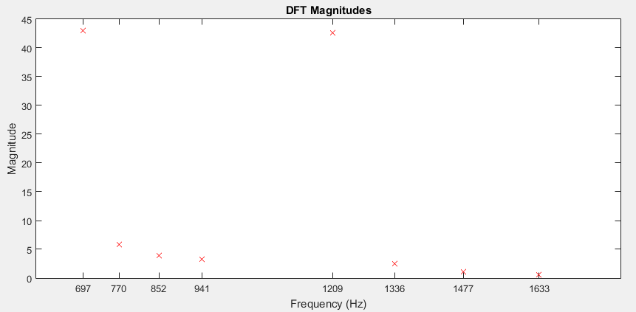
Figure 3: Plot of the DFT Magnitudes of a frame in the "tone" region

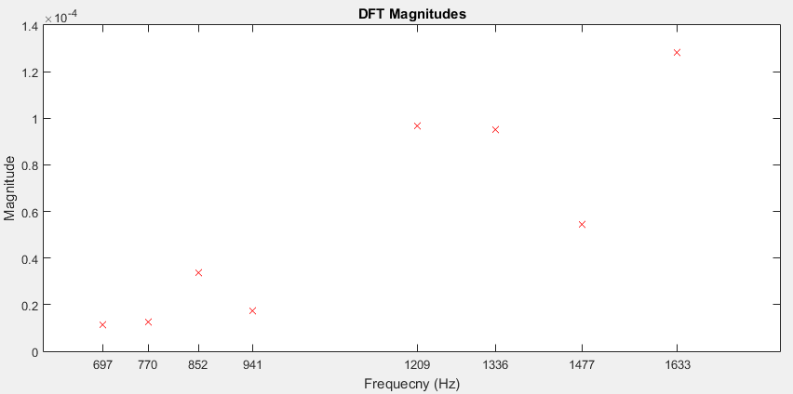
Figure 4: : Plot of the DFT Magnitudes of a frame in the "silent" region
NB: observe that the magnitudes of the frequencies in the “silent” region were much smaller and had random values compared to those in the “tone” region.
Next task was to find a way to distinguish between “tone” and “silent” regions and then retrieve the tone represented by the frames that weren’t “silent” ones. There is no formal way of doing this so had to think of heuristic methods. After some observation, noticed that the average magnitudes of frames that were from the “tone” region were much greater than the average of the frames in the “silent” region. This is illustrated in the graph below:
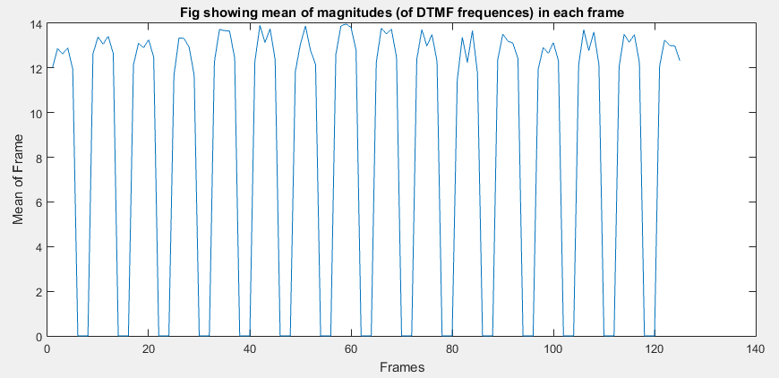To distinguish “silent” frames from “tone” frames, I decided that “silent” frames will be the frames with mean less than 10% of the average of the top 3 frames in the first 20 frames of the data. An illustration of this is shown below;
The peaks in the Figure above show presence of a tone. Frames with a mean below the dotted red line will be “silent” tones.

Detection Efficiency
After the design of the first prototype, the filter had to be improved to meet the ITU Recommendation as stated in ITU-I Recommendation Q.23 [3] and ITU-I Recommendation Q.24 [4]. Each administration has it's own specifications but most of them overlap each other. A summary of the recommendations is shown below (taken from ITU-T Q.24 [4]) :
Signal Frequencies:
- Low Band (Hz): 697, 770, 852, 941
- High Band (Hz): 1209, 1336, 1477, 1633
Frequency Tolerances:
- Max. accepted frequency offset: <=1.5% to 1.8% (depending on Administration)
- Min. rejected frequency offset: >= 3.5% to 7.5% (depending on Administration)
Power Levels per Frequency:
- Power range: -27dBm to 0dBm
- Maximum twist (Power difference between the two frequencies): 5 to 10 dBm (depends on Administration)
Signal Timing:
- Min. accepted tone duration: 40ms
- Min. pause (silence between tones): 30ms to 70ms (depending on Administration)
- Max. rejected tone duration: 20ms
- Max. signal interruption: 10ms

I had to generate Test Data to test all the conditions above. My Test Data was generated as follows:
- The sequence of tones will be randomly determined (choosing from the 16 available DTMF characters) and the length of the sequence will also vary randomly from 5 tones to 50 tones per file.
- The duration of each DTMF tone will be varied randomly between 40ms and 100ms.
- The duration of the pause between DTMF tones will be randomly varied between 30ms and 100ms.
- To vary the power of the signal between 0dBm and -27dBm, the amplitude of the signal will be varied from 0.045 (-27dBm) to 1.0 (0dBm).
- To random duration of pauses and tones will ensure that the frames used in the decoding process do not have the same alignment.

Changes made to the filter during/after testing

// Changes made so this information is not final yet
I ran tests decoding 40,000 test files that were generated using the specifications on the previous page. The success rate was 98%.

- The original frame size of 256 gave a success rate of only 89%. This is because of the frequency tolerance recommended by the ITU-T which meant that my decoder had to be more precise in the Frequency Domain. This came at a cost of less accuracy in the Time Domain though since the frame size was increased but this was dealt with in the next change described below. After some research I found out that the Goertzel Algorithm's performance is not affected by the size of the frame (I.e it does not have to be a power of 2). The new frames size is 370 which was worked out by testing several different frame sizes from 200 up to 400.
- The frames now overlap by 50% which effectively doubles the number of frames used in the decoding process. This offsets the effect of increasing the frame size described above. Precision in the time domain is still very important because, at a sampling frequency of 8kHz, each frame is now 64ms long which is longer than the minimum accepted tone length of 40ms and this affects the accuracy of the decoder in the Time Domain.
- Instead of checking for one specific DTMF frequency when using the Goertzel algorithm, I changed the decoder such that it check the range of frequencies within the maximum allowed tolerance of 1.5%. This unfortunately has a negative impact of performance because 274 frequencies are now being transformed by the Goertzel Algorithm instead of just 8. Nevertheless, the algorithm is still much faster than using FFT.

References

1) DODD, A. Z. The essential guide to telecommunications
2) (picture) http://www.engineersgarage.com/tutorials/dtmf-dual-tone-multiple-frequency
3) (pdf ITU q23) https://www.itu.int/rec/dologin_pub.asp?lang=e&id=T-REC-Q.23-198811-I!!PDF-E&type=items
4) (pdf itu q24) https://www.itu.int/rec/dologin_pub.asp?lang=e&id=T-REC-Q.24-198811-I!!PDF-E&type=items

